

FACULTY OF TECHNOLOGY AND ENGINEERING
DEVANG PATEL INSTITUTE OF ADVANCE TECHNOLOGY AND RESEARCH
DEPARTMENT OF INFORMATION TECHNOLOGY

A.Y. 2025-25 [EVEN]

LAB MANUAL

CEUC102: C++


Practical 1

Vending machine

Problem Statement:

(a) Define an enum Coin with constants ONE, TWO, FIVE, TEN.

(b) In main, set a snack price of 15 and a running total of 0; create a Scanner.

(c) Loop: read a coin name, use a switch expression to convert the Coin to its value (ONE→1, TWO→2, FIVE→5, and TEN→10), add it to the total, and print the total so far.

(d) Stop the loop once the total reaches 15 or more.

(e) Print the change to return (total − 15).

Expected output: TEN then FIVE prints “Paid. Change: 0”; TEN then TEN print “Paid. Change: 5”.

Solution:

import java.util.Scanner;

enum Coin {
ONE, TWO, FIVE, TEN
}

public class VendingMachine {
public static void main(String[] args) {
int price = 15;
int total = 0;
Scanner scanner = new Scanner(System.in);

while (total < price) {
System.out.print("Insert coin (ONE, TWO, FIVE, TEN): ");
String input = scanner.next().toUpperCase();
Coin coin;
try {
coin = Coin.valueOf(input);
} catch (IllegalArgumentException e) {
System.out.println("Invalid coin: " + input);
continue;
}

int value = switch (coin) {
case ONE -> 1;
case TWO -> 2;
case FIVE -> 5;
case TEN -> 10;
};

total += value;
System.out.println("Total so far: " + total);
}

System.out.println("Paid. Change: " + (total - price));
scanner.close();
}
}

Output:
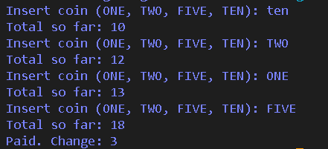

Toll Booth

Problem Statement:

(a) Define a record Vehicle(String number, String type).

(b) In main, keep a running toll total and three counters (bike, car, truck).

(c) Loop until the user types “done” for the number: build a Vehicle, use a switch expression on its type for the toll (bike→20, car→50, truck→150), add to the total, and increment that type’s counter.

(d) After the loop, print the total toll and the type with the highest count.

Expected output: two cars + one bike → “Total toll: 120”, “Most frequent: car”.

Solution:
import java.util.Scanner;

public class TollBooth {
public static void main(String[] args) {
record Vehicle(int number, String type) {}

Scanner scanner = new Scanner(System.in);
int totalToll = 0;
int bikeCount = 0;
int carCount = 0;
int truckCount = 0;

while (true) {
System.out.print("Enter vehicle number (or -1 to finish): ");
int number = scanner.nextInt();
if (number == -1) {
break;
}

System.out.print("Enter vehicle type: ");
String type = scanner.nextLine().trim().toLowerCase();

Vehicle vehicle = new Vehicle(number, type);
int toll = switch (vehicle.type()) {
case "bike" -> 20;
case "car" -> 50;
case "truck" -> 150;
default -> {
System.out.println("Unknown vehicle type: " + vehicle.type() + ". Toll treated as 0.");
yield 0;
}
};

switch (vehicle.type()) {
case "bike" -> bikeCount+=vehicle.number();
case "car" -> carCount+=vehicle.number();
case "truck" -> truckCount+=vehicle.number();
}
}

scanner.close();
totalToll = (bikeCount * 20) + (carCount * 50) + (truckCount * 150);
System.out.println("Total toll: " + totalToll);

String mostFrequent = "none";
int maxCount = Math.max(bikeCount, Math.max(carCount, truckCount));
if (maxCount == bikeCount) {
mostFrequent = "bike";
}
if (maxCount == carCount) {
mostFrequent = "car";
}
if (maxCount == truckCount) {
mostFrequent = "truck";
}

System.out.println("Most frequent: " + mostFrequent);
}
}

Output:
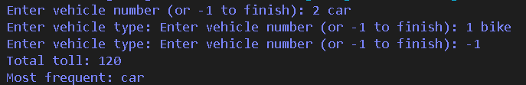

Mini Bank

Problem Statement:

MiniBank is the console banking application you will build across the whole semester. In

this first lab you set up your tools and create the project and its menu shell — the screen the

user navigates. Every later lab attaches one real banking feature behind these menu options.

1. Set up your environment: open the project in GitHub Codespaces (or install JDK 17+ and

an IDE locally), and create a private GitHub repository named oop-minibank-<rollno>;

add the faculty as a collaborator.

2. Create a public class named MiniBank that contains the main method.

3. Define a record named BankInfo with two String fields, name and branch (a record is a

short, read-only class; Java auto-generates its constructor and field accessors). Print one

BankInfo object as the application header.

4. Define an enum named MenuOption with the constants OPEN_ACCOUNT, DEPOSIT,

WITHDRAW, TRANSFER and EXIT — these are the actions MiniBank will offer.

5. Display the numbered menu to the user and read the chosen number with a Scanner.

6. Use a switch expression on the choice to print a short placeholder for that option (for

example, “Deposit — to be implemented in a later lab”). Keep showing the menu in a

loop until the user selects EXIT, then print a goodbye message.

Solution:
import java.util.Scanner;

public class MiniBank {
public static void main(String[] args) {
record Account(String Name, String branch) {}

enum MenuOption {
Open_ACCOUNT,
DEPOSIT,
WITHDRAW,
TRANSFER,
EXIT
}

Scanner scanner = new Scanner(System.in);

while (true) {
System.out.print("1. Open Account\n2. Deposit\n3. Withdraw\n4. Transfer\n5. Exit\nChoose an option: ");
int input = scanner.nextInt();
scanner.nextLine(); // Consume the newline character

MenuOption choice=switch (input) {
case 1 -> MenuOption.Open_ACCOUNT;
case 2 -> MenuOption.DEPOSIT;
case 3 -> MenuOption.WITHDRAW;
case 4 -> MenuOption.TRANSFER;
case 5 -> MenuOption.EXIT;
default -> null;
};

switch (choice) {
case Open_ACCOUNT:
System.out.print("Open_Account - to be implemented in a later lab\n");
break;
case DEPOSIT:
System.out.print("Deposit - to be implemented in a later lab\n");
break;
case WITHDRAW:
System.out.print("Withdraw - to be implemented in a later lab\n");
break;
case TRANSFER:
System.out.print("Transfer - to be implemented in a later lab\n");
break;
case EXIT:
System.out.println("Exiting... Thank you for using MiniBank!");
scanner.close();
return;
default:
System.out.println("Invalid option. Please try again.");
}
}
}
}

Output:
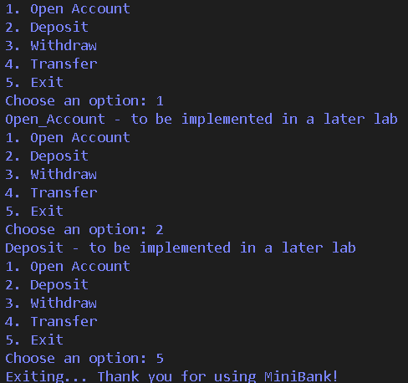

Practical 2

Classes, constructors, encapsulation, and static members
Problem Statement:
1. Smart thermostat: use private state, constructor chaining, bounded temperature controls, and a static count of active thermostats.
2. Cinema show: manage available seats with capacity, booking and cancellation, and a static total-booked count.
3. Advanced parking lot: simulate capacity-limited parking and revenue (the provided folder contains no ParkingLot.java).

Available solutions:

thermostat.java
class Thermostat {
private String location;
private int temperature;
private static final int MIN = 16;
private static final int MAX = 30;
private static int activeCount = 0;
Thermostat(String location, int startTemp) {
this.location = location;
if (startTemp >= MIN && startTemp <= MAX) {
this.temperature = startTemp;
} else {
this.temperature = 22;
}
activeCount++;
}
Thermostat(String location) {
this(location, 22);
}
void raise() {
if (temperature < MAX) {
temperature++;
} else {
System.out.println("Already at maximum (30)");
}
}
void lower() {
if (temperature > MIN) {
temperature--;
} else {
System.out.println("Already at minimum (16)");
}
}
int getTemperature() {
return temperature;
}
static int getActiveCount() {
return activeCount;
}
}
public class thermostat {
public static void main(String[] args) {
Thermostat t1 = new Thermostat("Living Room");
Thermostat t2 = new Thermostat("Bedroom", 24);
for (int i = 0; i < 10; i++) {
t1.raise();
System.out.println(t1.getTemperature());
}
for (int i = 0; i < 20; i++) {
t1.lower();
System.out.println(t1.getTemperature());
}
System.out.println(Thermostat.getActiveCount());
}
}

CinemaShow.java
public class CinemaShow {
private String title;
private int seatsAvailable;
private final int capacity;
private static int totalBooked = 0;
public CinemaShow(String title, int capacity) {
this.title = title;
this.capacity = capacity;
this.seatsAvailable = capacity;
}
public CinemaShow(String title) {
this(title, 100);
}
public boolean book(int n) {
if (n <= seatsAvailable) {
seatsAvailable -= n;
totalBooked += n;
return true;
}
return false;
}
public void cancel(int n) {
seatsAvailable = Math.min(capacity, seatsAvailable + n);
}
public int getSeatsAvailable() {
return seatsAvailable;
}
public static int getTotalBooked() {
return totalBooked;
}
public static void main(String[] args) {
CinemaShow show = new CinemaShow("Evening Show", 10);
System.out.println("Show: " + show.title);
System.out.println("Book 4: " + show.book(4));
System.out.println("Seats available: " + show.getSeatsAvailable());
System.out.println("Book 8: " + show.book(8));
System.out.println("Seats available: " + show.getSeatsAvailable());
show.cancel(2);
System.out.println("Cancel 2");
System.out.println("Seats available: " + show.getSeatsAvailable());
System.out.println("Book 6: " + show.book(6));
System.out.println("Seats available: " + show.getSeatsAvailable());
System.out.println("Total booked: " + getTotalBooked());
}
}

Output Screenshot:
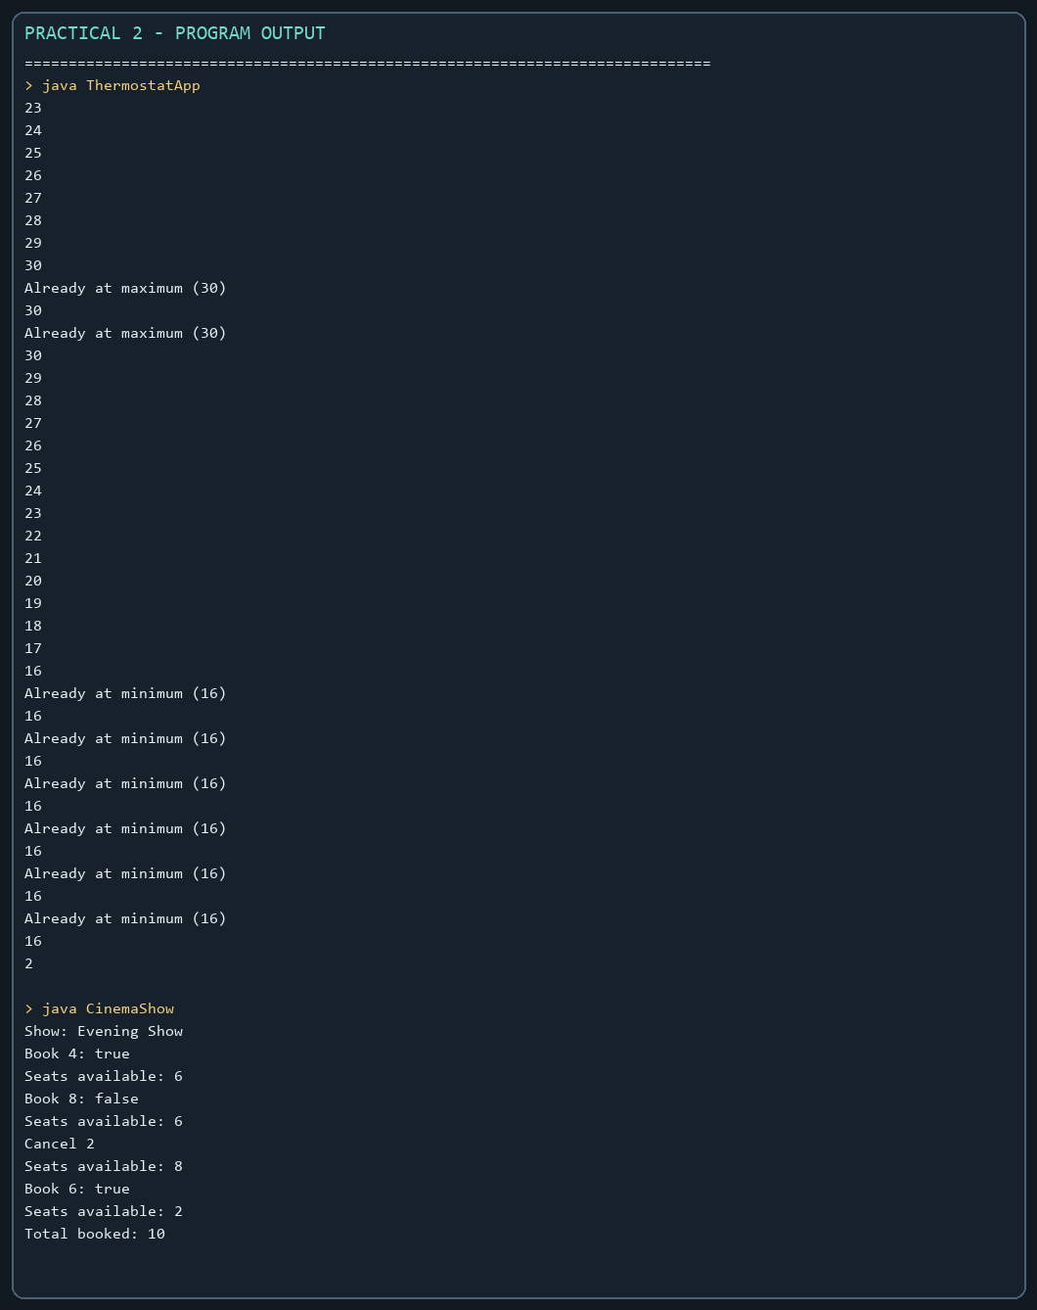

MiniBank Project Work:
Milestone completed: introduced encapsulated Customer and Account model classes, read-only account identifiers, controlled balance changes through deposit/withdraw, and constructors. These classes are extended in later practicals.

Minibank/src/main/java/minibank/model/Account.java ? encapsulated account state
protected Account(String accountNumber, String ownerName, long balance) {
this.accountNumber = Objects.requireNonNull(accountNumber);
this.ownerName = Objects.requireNonNull(ownerName);
this.balance = balance;
}

Minibank/src/main/java/minibank/model/Account.java ? controlled deposit
public synchronized void deposit(long amount) throws InvalidAmountException {
if (amount <= 0) throw new InvalidAmountException("Deposit must be positive.");
balance = Math.addExact(balance, amount);
}

Minibank/src/main/java/minibank/model/Customer.java ? customer model
package minibank.model;
import java.io.Serializable;
import java.util.Objects;
import minibank.model.annotation.Id;
import minibank.model.annotation.MaxLength;
public final class Customer implements Cloneable, Serializable {
private static final long serialVersionUID = 1L;
@Id
private final String customerId;
@MaxLength(60)
private final String name;
private final String email;
private final String mobile;
private Address address;
public Customer(String customerId, String name, String email, String mobile) {
this.customerId = Objects.requireNonNull(customerId);
this.name = Objects.requireNonNull(name);
this.email = Objects.requireNonNull(email);
this.mobile = Objects.requireNonNull(mobile);
}
public String getCustomerId() { return customerId; }
public String getName() { return name; }
public String getEmail() { return email; }
public String getMobile() { return mobile; }
public Address getAddress() { return address; }
public void setAddress(Address address) { this.address = address; }
@Override
public Customer clone() {
try {
Customer copy = (Customer) super.clone();
if (address != null) copy.address = address.clone();
return copy;
} catch (CloneNotSupportedException exception) {
throw new AssertionError(exception);
}
}
public static final class Address implements Serializable, Cloneable {
private static final long serialVersionUID = 1L;
private final String line;
private final String city;
private final String pincode;
public Address(String line, String city, String pincode) {
this.line = Objects.requireNonNull(line);
this.city = Objects.requireNonNull(city);
this.pincode = Objects.requireNonNull(pincode);
}
public String getLine() { return line; }
public String getCity() { return city; }
public String getPincode() { return pincode; }
@Override public Address clone() {
try { return (Address) super.clone(); }
catch (CloneNotSupportedException exception) { throw new AssertionError(exception); }
}
}
}

Practical 3

Object equality and hashing
Problem Statement:
1. Distinct points: override toString, equals, and hashCode; count distinct coordinates in a Point array.
2. Duplicate card check: compare cards by rank and suit and report the first duplicate.
3. Fractions: reduce fractions to lowest terms and compare equivalent values.
Expected Output: The sample programs demonstrate the required behavior; see the captured console output below.

Solution:

Card.java
import java.util.Objects;
public final class Card {
private final String rank;
private final String suit;
public Card(String rank, String suit) {
this.rank = Objects.requireNonNull(rank);
this.suit = Objects.requireNonNull(suit);
}
@Override
public String toString() {
return rank + " of " + suit;
}
@Override
public boolean equals(Object other) {
return this == other || other instanceof Card card
&& rank.equals(card.rank) && suit.equals(card.suit);
}
@Override
public int hashCode() {
return Objects.hash(rank, suit);
}
}

CardDemo.java
public class CardDemo {
public static void main(String[] args) {
Card[] cards = {new Card("King", "Hearts"), new Card("Ace", "Spades"),
new Card("Ace", "Spades"), new Card("Queen", "Clubs")};
Card[] seen = new Card[cards.length];
int count = 0;
for (Card card : cards) {
boolean duplicate = false;
for (int i = 0; i < count; i++) {
if (card.equals(seen[i])) {
duplicate = true;
System.out.println("Duplicate found: " + card);
break;
}
}
if (!duplicate) seen[count++] = card;
}
}
}

Fraction.java
import java.util.Objects;
public final class Fraction {
private final int num;
private final int den;
public Fraction(int numerator, int denominator) {
if (denominator == 0) throw new IllegalArgumentException("Denominator cannot be zero.");
int sign = denominator < 0 ? -1 : 1;
int gcd = gcd(Math.abs(numerator), Math.abs(denominator));
num = sign * numerator / gcd;
den = Math.abs(denominator) / gcd;
}
private static int gcd(int a, int b) {
while (b != 0) {
int remainder = a % b;
a = b;
b = remainder;
}
return a == 0 ? 1 : a;
}
@Override
public String toString() {
return num + "/" + den;
}
@Override
public boolean equals(Object other) {
return this == other || other instanceof Fraction fraction
&& num == fraction.num && den == fraction.den;
}
@Override
public int hashCode() {
return Objects.hash(num, den);
}
}

FractionDemo.java
public class FractionDemo {
public static void main(String[] args) {
Fraction half = new Fraction(1, 2);
Fraction[] equivalent = {new Fraction(1, 2), new Fraction(2, 4), new Fraction(3, 6)};
for (Fraction fraction : equivalent) {
System.out.println(fraction + " equals 1/2: " + fraction.equals(half));
}
}
}

Point.java
import java.util.Objects;
public final class Point {
private final int x;
private final int y;
public Point(int x, int y) {
this.x = x;
this.y = y;
}
@Override
public String toString() {
return "(" + x + ", " + y + ")";
}
@Override
public boolean equals(Object other) {
return this == other || other instanceof Point point && x == point.x && y == point.y;
}
@Override
public int hashCode() {
return Objects.hash(x, y);
}
}

PointDemo.java
public class PointDemo {
public static void main(String[] args) {
Point[] points = {
new Point(1, 2), new Point(3, 4), new Point(1, 2),
new Point(5, 6), new Point(3, 4)
};
int distinct = 0;
for (int i = 0; i < points.length; i++) {
boolean appeared = false;
for (int j = 0; j < i; j++) {
if (points[i].equals(points[j])) {
appeared = true;
break;
}
}
if (!appeared) distinct++;
}
System.out.println("Distinct: " + distinct);
}
}

MiniBank Project Work:

MiniBank progress ? Practical 3
Completed: readable Account output and equality by account number, plus Customer Address and clone support. The full project later carries these model classes forward as additional practical features are added.
Single project location: Java Programs\Minibank

Progressive source excerpts:

Minibank/src/main/java/minibank/model/Account.java ? object equality
public final boolean equals(Object other) {
return this == other || other instanceof Account account
&& accountNumber.equals(account.accountNumber);
}

Minibank/src/main/java/minibank/model/Account.java ? hash code
public final int hashCode() { return accountNumber.hashCode(); }

Minibank/src/main/java/minibank/model/Account.java ? readable output
public String toString() {
return accountNumber + " | " + ownerName + " | " + getBalance();
}

Minibank/src/main/java/minibank/model/Customer.java ? customer clone
public Customer clone() {
try {
Customer copy = (Customer) super.clone();
if (address != null) copy.address = address.clone();
return copy;
} catch (CloneNotSupportedException exception) {
throw new AssertionError(exception);
}
}

Minibank/src/main/java/minibank/model/Customer.java ? nested Address
public static final class Address implements Serializable, Cloneable {
private static final long serialVersionUID = 1L;
private final String line;
private final String city;
private final String pincode;
public Address(String line, String city, String pincode) {
this.line = Objects.requireNonNull(line);
this.city = Objects.requireNonNull(city);
this.pincode = Objects.requireNonNull(pincode);
}
public String getLine() { return line; }
public String getCity() { return city; }
public String getPincode() { return pincode; }
@Override public Address clone() {
try { return (Address) super.clone(); }
catch (CloneNotSupportedException exception) { throw new AssertionError(exception); }
}
}
}

Output Screenshot:
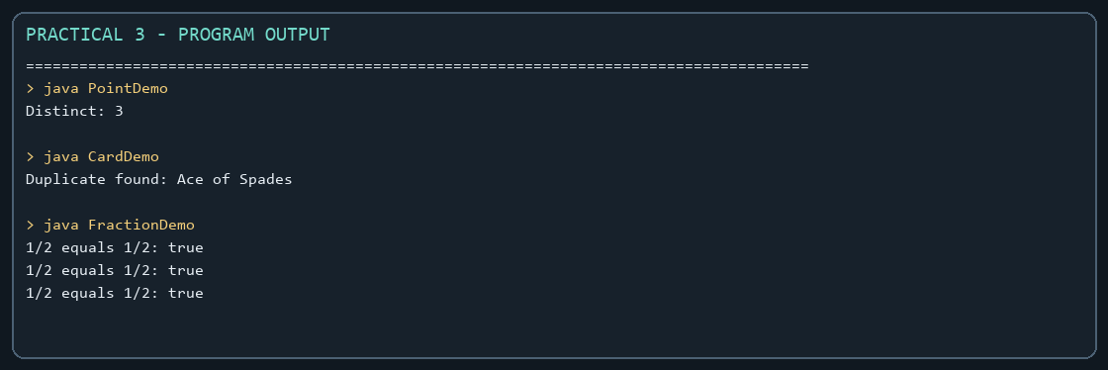

Practical 4

Strings, regular expressions, and validation
Problem Statement:
1. Password strength: check four rules and label each password Weak, Medium, or Strong.
2. Chat-log filter: skip malformed lines, match a case-insensitive keyword, and build a report.
3. Template filler: replace named placeholders and use [?] for a missing value.
Expected Output: The sample programs demonstrate the required behavior; see the captured console output below.

Solution:

ChatFilter.java
import java.util.Scanner;
public class ChatFilter {
public static void main(String[] args) {
String[] logs = {"10:05 alice Hello there", "10:06 bob I am online",
"malformed", "10:07 cara Good evening"};
try (Scanner scanner = new Scanner(System.in)) {
System.out.print("Keyword: ");
String keyword = scanner.nextLine().trim().toLowerCase();
int matches = 0;
StringBuilder report = new StringBuilder();
for (String line : logs) {
String[] parts = line.split(" ", 3);
if (parts.length < 3) continue;
if (parts[2].toLowerCase().contains(keyword)) {
matches++;
report.append(parts[0]).append(' ').append(parts[1]).append(": ")
.append(parts[2]).append(System.lineSeparator());
}
}
System.out.println("Matches: " + matches);
System.out.print(report);
}
}
}

PasswordChecker.java
public class PasswordChecker {
private static final String[] RULES = {
"at least 8 characters", "an uppercase letter", "a digit", "a special character"
};
public static String strength(String password) {
int score = 0;
if (password.length() >= 8) score++;
if (password.matches(".*[A-Z].*")) score++;
if (password.matches(".*\\d.*")) score++;
if (password.matches(".*[^a-zA-Z0-9].*")) score++;
return score <= 1 ? "Weak" : score <= 3 ? "Medium" : "Strong";
}
public static void main(String[] args) {
for (String password : new String[]{"abc", "Abcd1234!", "hello123", "OnlyUppercase"}) {
System.out.println("Password: " + password);
boolean[] passed = {password.length() >= 8, password.matches(".*[A-Z].*"),
password.matches(".*\\d.*"), password.matches(".*[^a-zA-Z0-9].*")};
for (int i = 0; i < RULES.length; i++) {
System.out.println(" " + RULES[i] + ": " + passed[i]);
}
System.out.println("Strength: " + strength(password));
}
}
}

TemplateFiller.java
import java.util.regex.Matcher;
import java.util.regex.Pattern;
public class TemplateFiller {
public static void main(String[] args) {
String template = "Dear {name}, order {id} ships {date}.";
String[] names = {"name", "id"};
String[] values = {"Riya", "A07"};
Matcher matcher = Pattern.compile("\\{(\\w+)\\}").matcher(template);
StringBuilder output = new StringBuilder();
int previous = 0;
while (matcher.find()) {
output.append(template, previous, matcher.start());
String replacement = "[?]";
for (int i = 0; i < names.length; i++) {
if (names[i].equals(matcher.group(1))) {
replacement = values[i];
break;
}
}
output.append(replacement);
previous = matcher.end();
}
output.append(template, previous, template.length());
System.out.println(output);
}
}

MiniBank Project Work:

MiniBank progress ? Practical 4
Completed: compiled regex validators, TransactionType and Command records, command parsing with invalid-input checks, and StringBuilder statement formatting.
Single project location: Java Programs\Minibank

Progressive source excerpts:

Minibank/src/main/java/minibank/util/Validator.java
package minibank.util;
import java.util.regex.Pattern;
public final class Validator {
private static final Pattern MOBILE = Pattern.compile("^[6-9][0-9]{9}$");
private static final Pattern EMAIL = Pattern.compile("^[A-Za-z0-9+_.-]+@[A-Za-z0-9.-]+\\.[A-Za-z]{2,}$");
private static final Pattern PAN = Pattern.compile("^[A-Z]{5}[0-9]{4}[A-Z]$");
private static final Pattern IFSC = Pattern.compile("^[A-Z]{4}0[A-Z0-9]{6}$");
private static final Pattern ACCOUNT = Pattern.compile("^AC[0-9]{4,8}$");
private Validator() { }
public static boolean isValidMobile(String value) { return matches(MOBILE, value); }
public static boolean isValidEmail(String value) { return matches(EMAIL, value); }
public static boolean isValidPan(String value) { return matches(PAN, value); }
public static boolean isValidIfsc(String value) { return matches(IFSC, value); }
public static boolean isValidAccountNumber(String value) { return matches(ACCOUNT, value); }
private static boolean matches(Pattern pattern, String value) {
return value != null && pattern.matcher(value).matches();
}
}

Minibank/src/main/java/minibank/model/CommandParser.java
package minibank.model;
public final class CommandParser {
private CommandParser() { }
public static Command parse(String line) {
if (line == null) throw new IllegalArgumentException("Command cannot be null.");
String[] parts = line.trim().split("\\s+");
if (parts.length != 3) {
throw new IllegalArgumentException("Expected: TYPE ACCOUNT_NUMBER AMOUNT");
}
try {
return new Command(TransactionType.valueOf(parts[0].toUpperCase()),
parts[1], Long.parseLong(parts[2]));
} catch (IllegalArgumentException exception) {
throw new IllegalArgumentException("Invalid command type or amount.", exception);
}
}
}

Minibank/src/main/java/minibank/util/StatementFormatter.java
package minibank.util;
import minibank.model.Account;
public final class StatementFormatter {
private StatementFormatter() { }
public static String buildStatement(Account account) {
return new StringBuilder("MINIBANK ACCOUNT STATEMENT\n")
.append("Account: ").append(account.getAccountNumber()).append('\n')
.append("Owner: ").append(account.getOwnerName()).append('\n')
.append("Balance: ").append(account.getBalance()).append('\n')
.append("Interest rate: ").append(account.interestRate()).append("%\n")
.toString();
}
}

Output Screenshot:
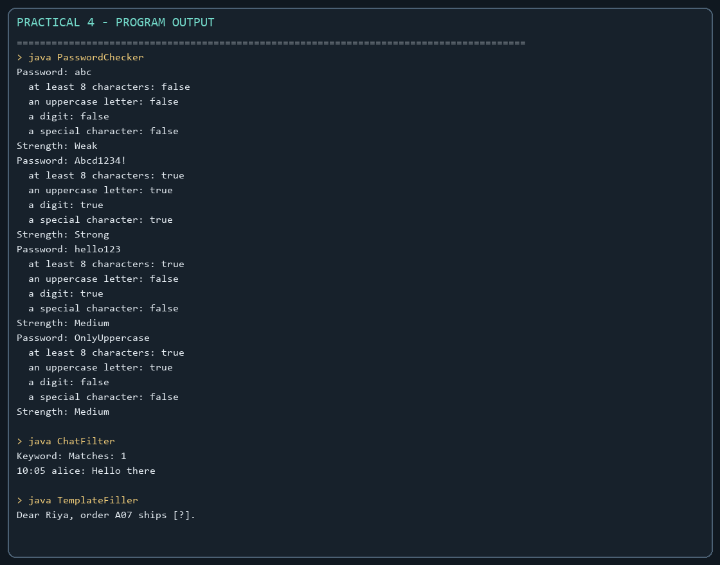

Practical 5

Abstract classes, inheritance, and polymorphism
Problem Statement:
1. Shape areas: use abstract Shape and Circle, Rectangle, and Triangle subclasses; process a mixed array polymorphically while tracking total and largest area.
2. Payroll: use an abstract Employee and FullTime, PartTime, and Intern subclasses to calculate salaries polymorphically.
3. Advanced media fees: design media types with different late-fee calculations. Only ShapeDemo.java is present in the provided Practical 5 folder.

Available solution:

ShapeDemo.java
abstract class Shape {
abstract double area();
}
class Circle extends Shape {
private double radius;
Circle(double radius) {
this.radius = radius;
}
@Override
double area() {
return Math.PI * radius * radius;
}
}
class Rectangle extends Shape {
private double length;
private double width;
Rectangle(double length, double width) {
this.length = length;
this.width = width;
}
@Override
double area() {
return length * width;
}
}
class Triangle extends Shape {
private double base;
private double height;
Triangle(double base, double height) {
this.base = base;
this.height = height;
}
@Override
double area() {
return 0.5 * base * height;
}
}
public class ShapeDemo {
public static void main(String[] args)
{
Shape[] shapes={
new Circle(3),
new Rectangle(4, 5),
new Triangle(6, 7),
new Circle(2)
};
double totalArea=0;
double largestArea=0;
for (Shape shape : shapes)
{
double area=shape.area();
System.out.printf("Area: %.2f%n", area);
totalArea += area;
if (area > largestArea) {
largestArea = area;
}
System.out.printf("Largest Area so far: %.2f%n", largestArea);
}
System.out.printf("Total Area: %.2f%n", totalArea);
System.out.printf("Largest Area: %.2f%n", largestArea);
}
}

Output Screenshot:
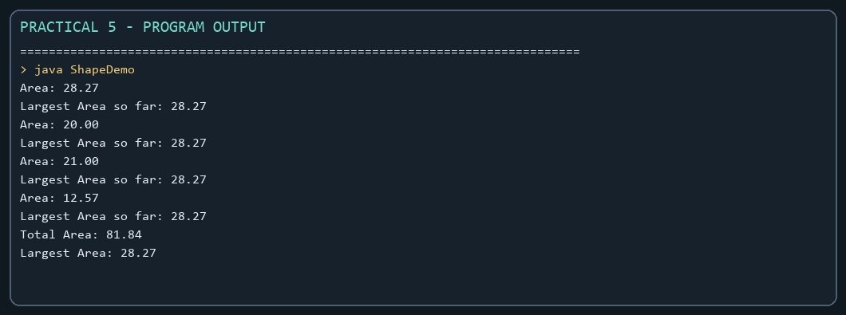

MiniBank Project Work:
Milestone completed: Account becomes an abstract type with concrete SavingsAccount, CurrentAccount, and FixedDepositAccount subclasses. Interest and withdrawal rules are selected through runtime polymorphism.

Minibank/src/main/java/minibank/model/Account.java ? abstract account contract
public abstract boolean canWithdraw(long amount);
@Override
public final int compareTo(Account other) {
return accountNumber.compareTo(other.accountNumber);
}

Minibank/src/main/java/minibank/model/SavingsAccount.java
package minibank.model;
public final class SavingsAccount extends Account implements Premium {
private static final long serialVersionUID = 1L;
private final long minBalance;
public SavingsAccount(String accountNumber, String ownerName, long balance, long minBalance) {
super(accountNumber, ownerName, balance);
if (minBalance < 0) throw new IllegalArgumentException("Minimum balance cannot be negative.");
this.minBalance = minBalance;
}
public long getMinBalance() { return minBalance; }
@Override public double interestRate() { return 4.0; }
@Override public boolean canWithdraw(long amount) {
long balance = getBalance();
return amount > 0 && balance >= minBalance && amount <= balance - minBalance;
}
}

Minibank/src/main/java/minibank/model/CurrentAccount.java
package minibank.model;
public final class CurrentAccount extends Account {
private static final long serialVersionUID = 1L;
private final long overdraftLimit;
public CurrentAccount(String accountNumber, String ownerName, long balance, long overdraftLimit) {
super(accountNumber, ownerName, balance);
if (overdraftLimit < 0) throw new IllegalArgumentException("Overdraft cannot be negative.");
this.overdraftLimit = overdraftLimit;
}
public long getOverdraftLimit() { return overdraftLimit; }
@Override public double interestRate() { return 0.0; }
@Override public boolean canWithdraw(long amount) {
long balance = getBalance();
return amount > 0 && (amount <= balance || amount - balance <= overdraftLimit);
}
}

Minibank/src/main/java/minibank/model/FixedDepositAccount.java
package minibank.model;
public final class FixedDepositAccount extends Account {
private static final long serialVersionUID = 1L;
public FixedDepositAccount(String accountNumber, String ownerName, long balance) {
super(accountNumber, ownerName, balance);
}
@Override public double interestRate() { return 7.0; }
@Override public boolean canWithdraw(long amount) { return false; }
}

